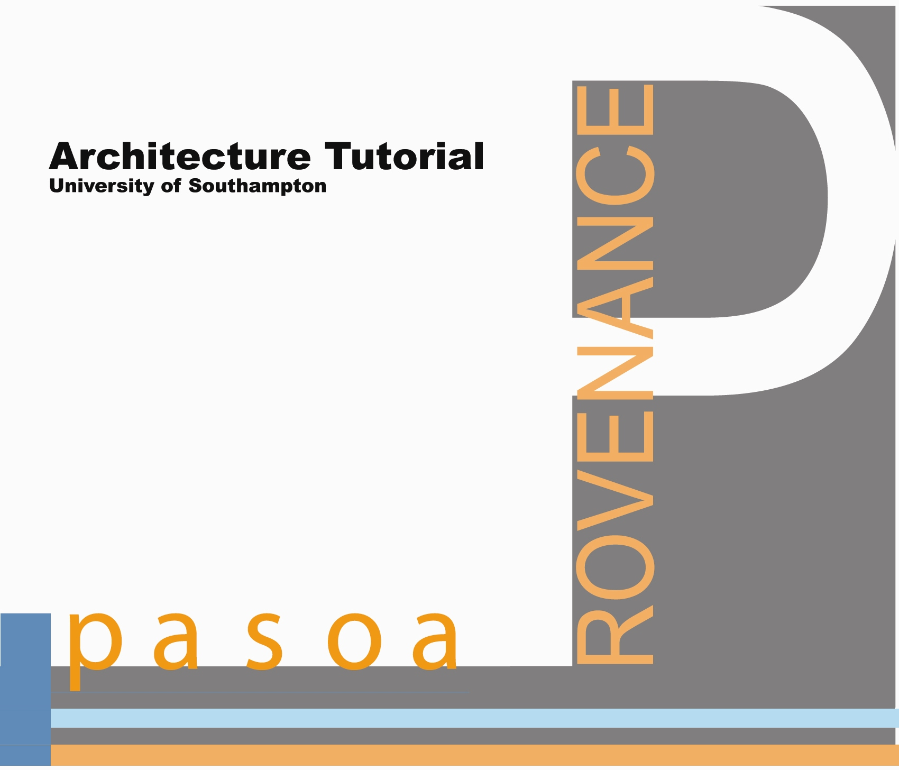

Architecture Tutorial, March 30-31, 2006
University of Southampton
(presented by PASOA, EU Provenance)

Figure List Page

Figure 1. Provenance Logical Architecture 1
Figure 2. Provenance Store Security Architecture 2
Figure 3. Interaction P-Assertion schema 3
Figure 4. Actor state P-Assertion schema 3
Figure 5. Relationship P-Assertion schema 4
Figure 6. P-Structure schema 5
Figure 7. View schema (in P-Structure) 5
Figure 8. Recording schema 6
Figure 9. Relationship target schema 7

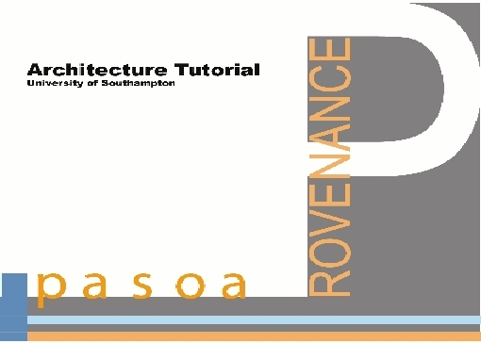

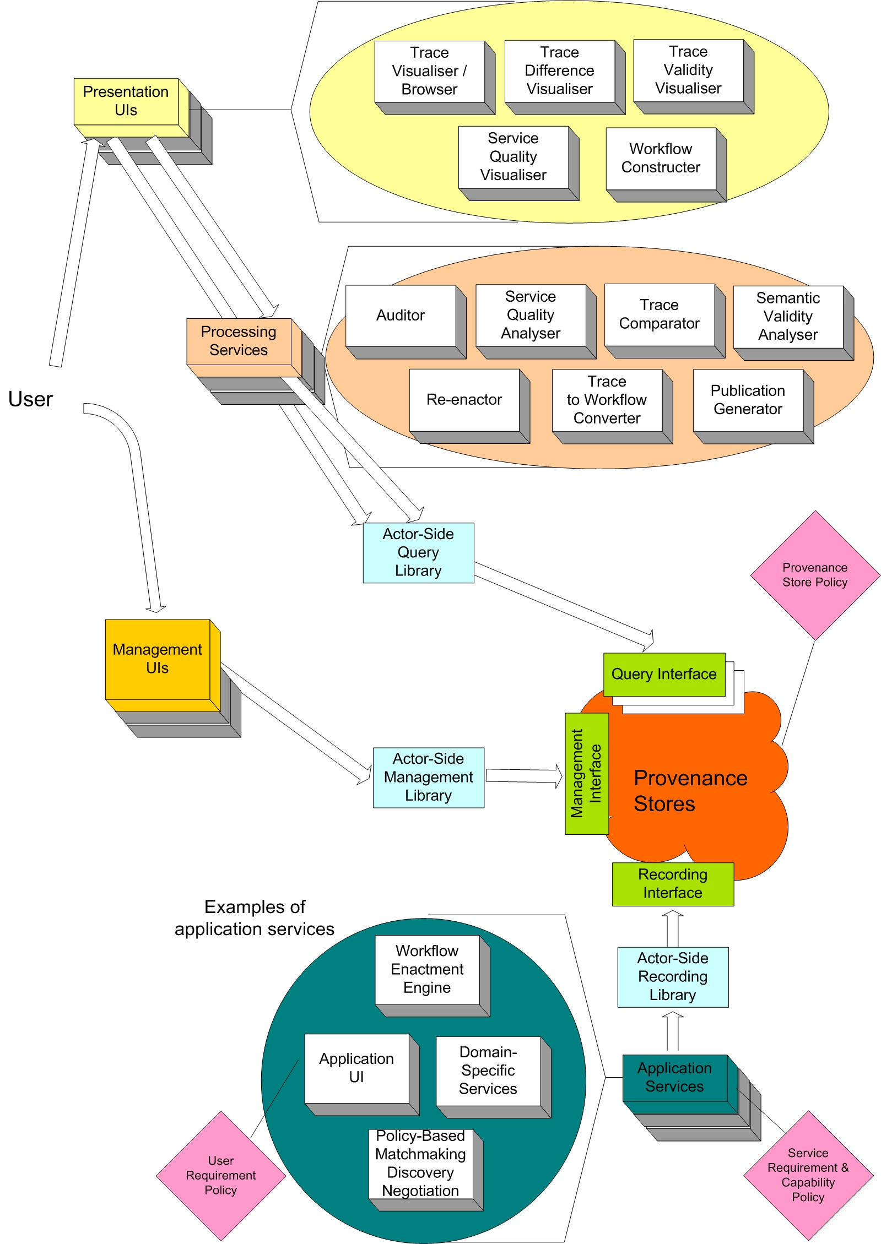

Figure 1. Provenance Logical Architecture

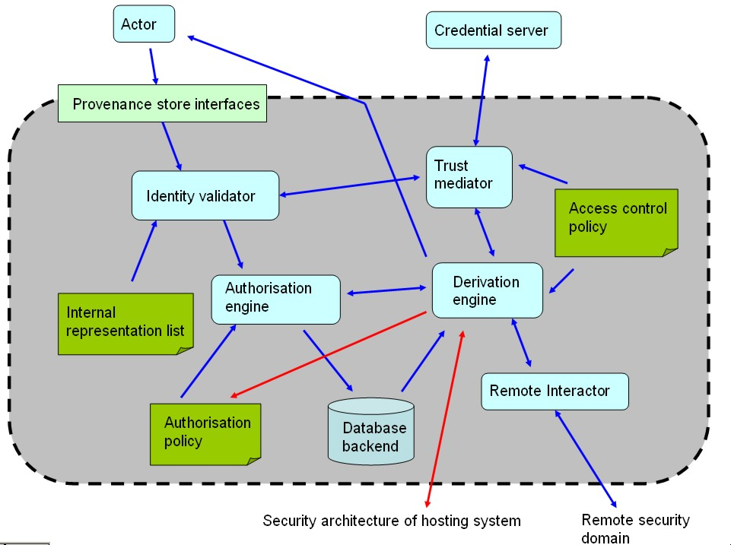

Figure 2. Provenance Store Security Architecture

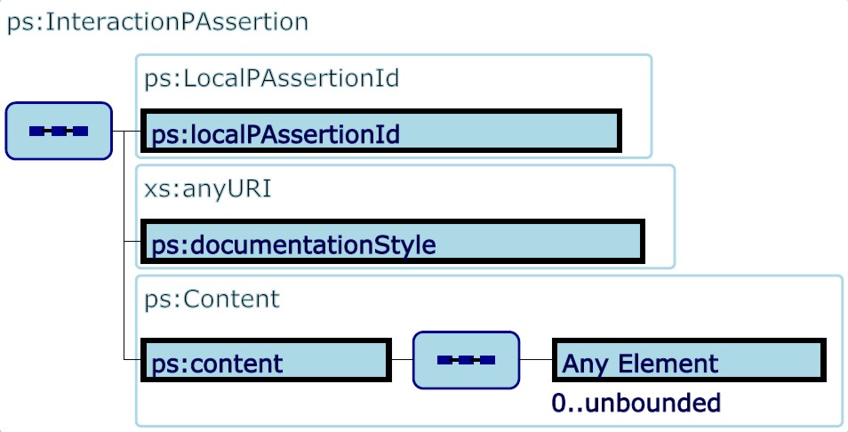

Figure 3. Interaction P-Assertion schema

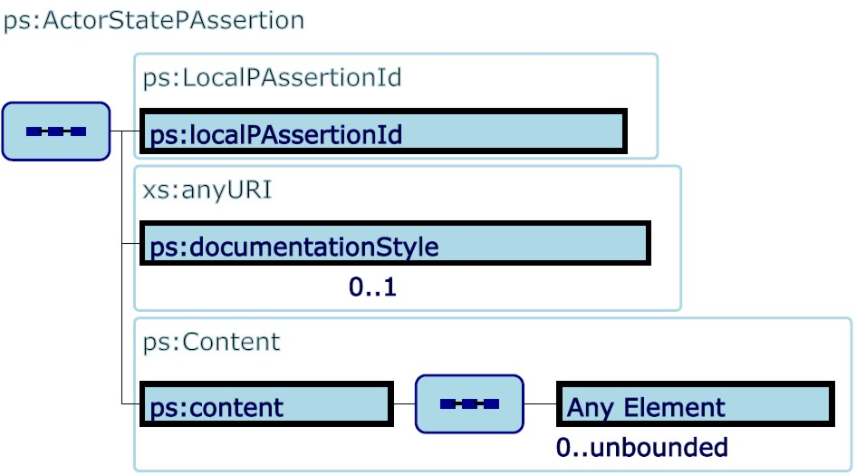

Figure 4. Actor state P-Assertion schema

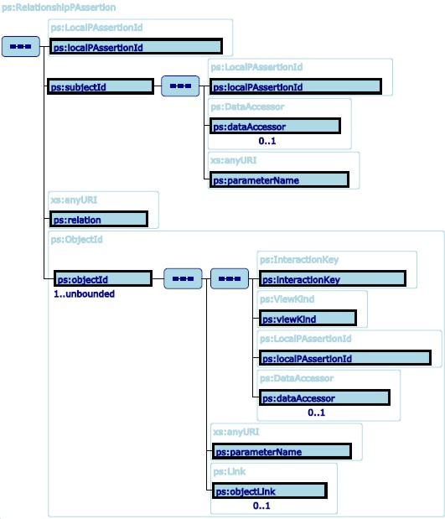

Figure 5. Relationship P-Assertion schema

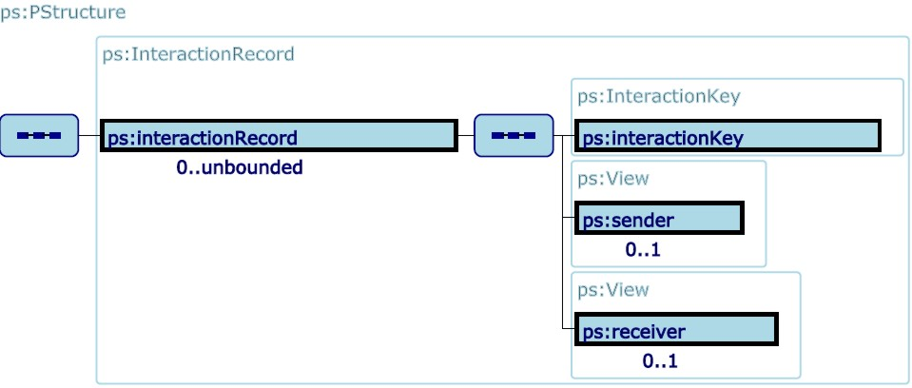

Figure 6. P-Structure schema

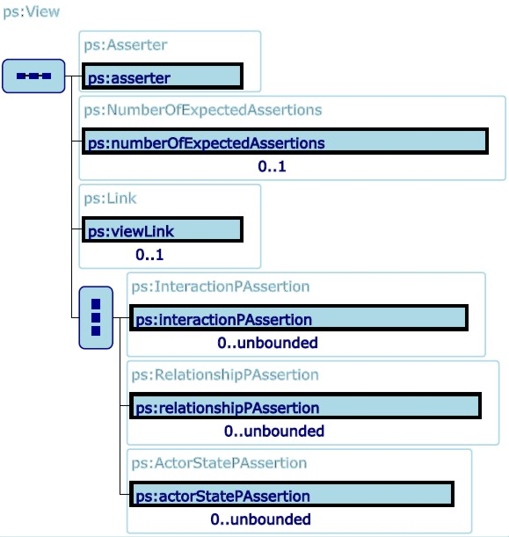

Figure 7. View schema (in P-Structure)

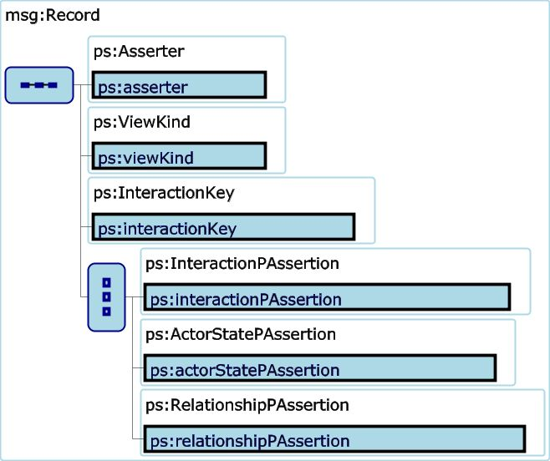

Figure 8. Recording schema

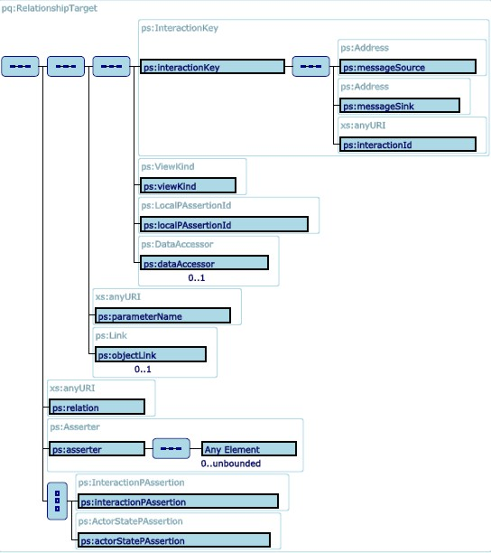

Figure 9. Relationship target schema

